# Ex:189 JAVA DATABASE CONNECTIVITY – MYSQL

Program:

**import** java.sql.DriverManager;

**import** java.sql.Connection;

**import** java.sql.SQLException;

**import** java.sql.*;

**public** **class** mysqlconnect {

**public** **static** **void** main(String args[]){

**try**{

Class.*forName*("com.mysql.jdbc.Driver");

Connectioncon=DriverManager.*getConnection*("jdbc:mysql://localhost/nametable","root", "");

//here sonoo is database name, root is username and password

Statement stmt=con.createStatement();

ResultSet rs=stmt.executeQuery("select * from

nametable");

**while**(rs.next())

System.***out***.println("FirstName=" +rs.getString(1)+"\t " +"LastName=" +rs.getString(2)+" ");

con.close();

}**catch**(Exception e){ System.***out***.println(e);}

}

}

**Output:**

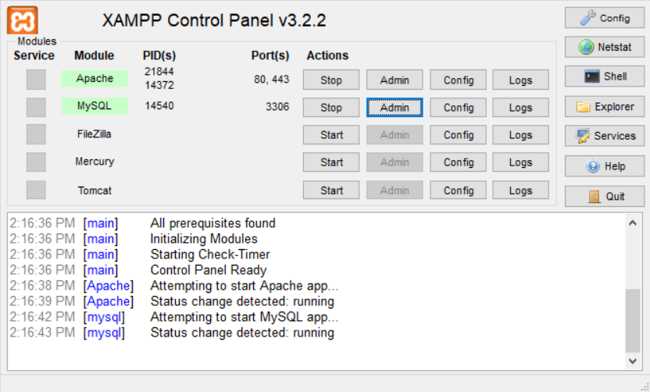

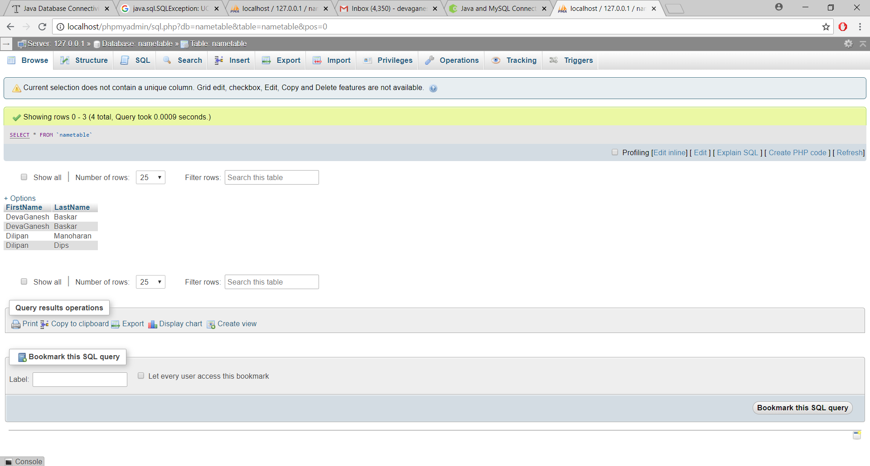

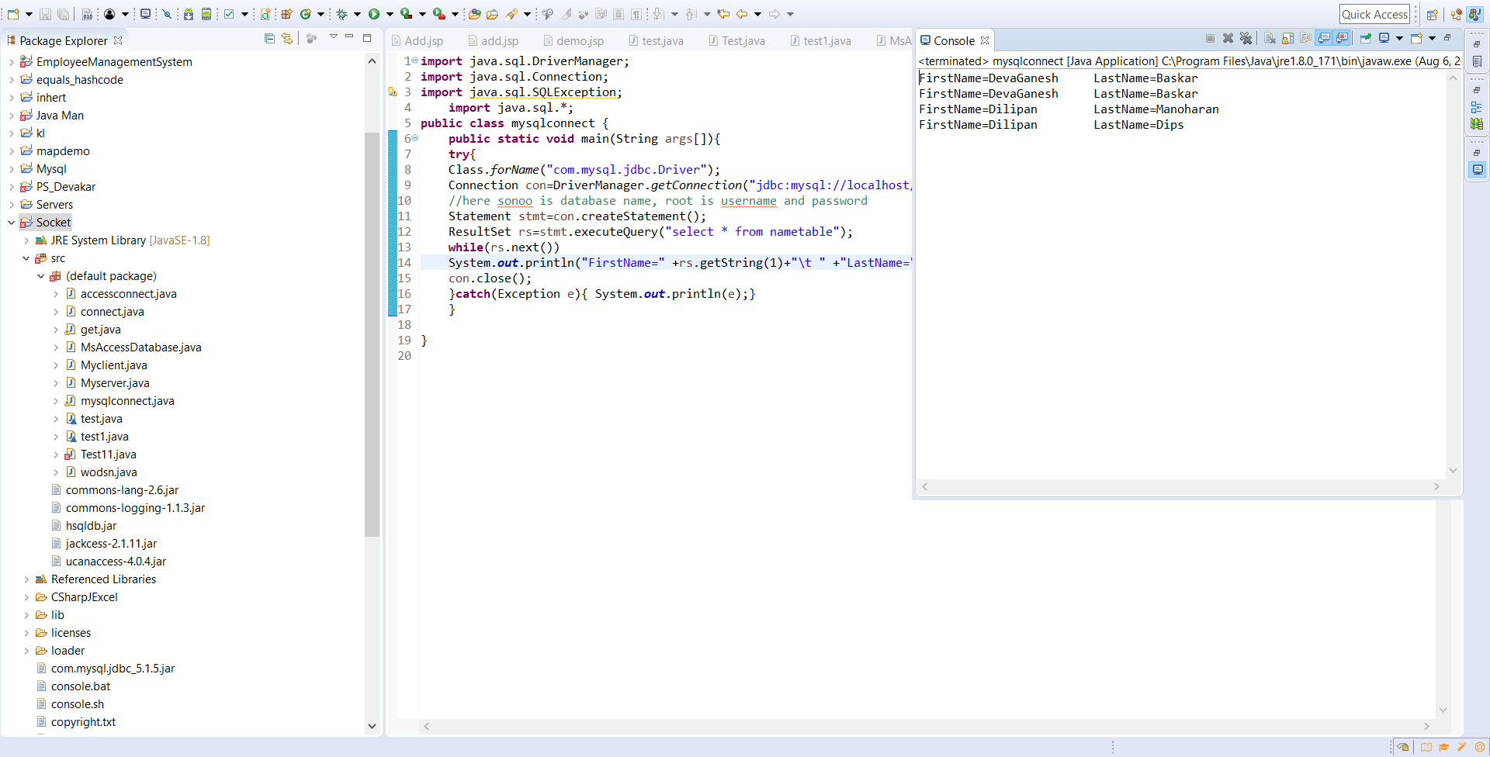

**RESULT:**

Ex:190  **JAVA DATABASE CONNECTIVITY – EXCELSHEET**

**Program:**

**import** java.io.File;

**import** java.io.IOException;

**import** jxl.Cell;

**import** jxl.CellType;

**import** jxl.Sheet;

**import** jxl.Workbook;

**import** jxl.read.biff.BiffException;

**public** **class** connect {

**private** String inputFile;

**public** **void** setInputFile(String inputFile) {

**this**.inputFile = inputFile;

}

**public** **void** read() **throws** IOException{

File inputWorkbook = **new** File(inputFile);

Workbook w;

**try** {

w = Workbook.*getWorkbook*(inputWorkbook);

// Get the first sheet

Sheet sheet = w.getSheet(0);

//loop over first 10 column and lines

**for**(**int** j= 0;j<sheet.getColumns();j++){

**for** (**int** i=0;i<sheet.getRows(); i++) {

Cell cell = sheet.getCell(j,i);

CellType type = cell.getType();

**if**(type == CellType.***LABEL***) {

System.***out***.println("I got a label " + cell.getContents());

}

**if**(type == CellType.***NUMBER***) {

System.***out***.println("I got a number " + cell.getContents());

}

}

}

} **catch**(BiffException e) {

e.printStackTrace();

}

}

**public** **static** **void** main(String[] args) **throws** IOException {

connect test= **new** connect();

test.setInputFile("F:\\Book1.xls");

test.read();

}

}

**Output:**

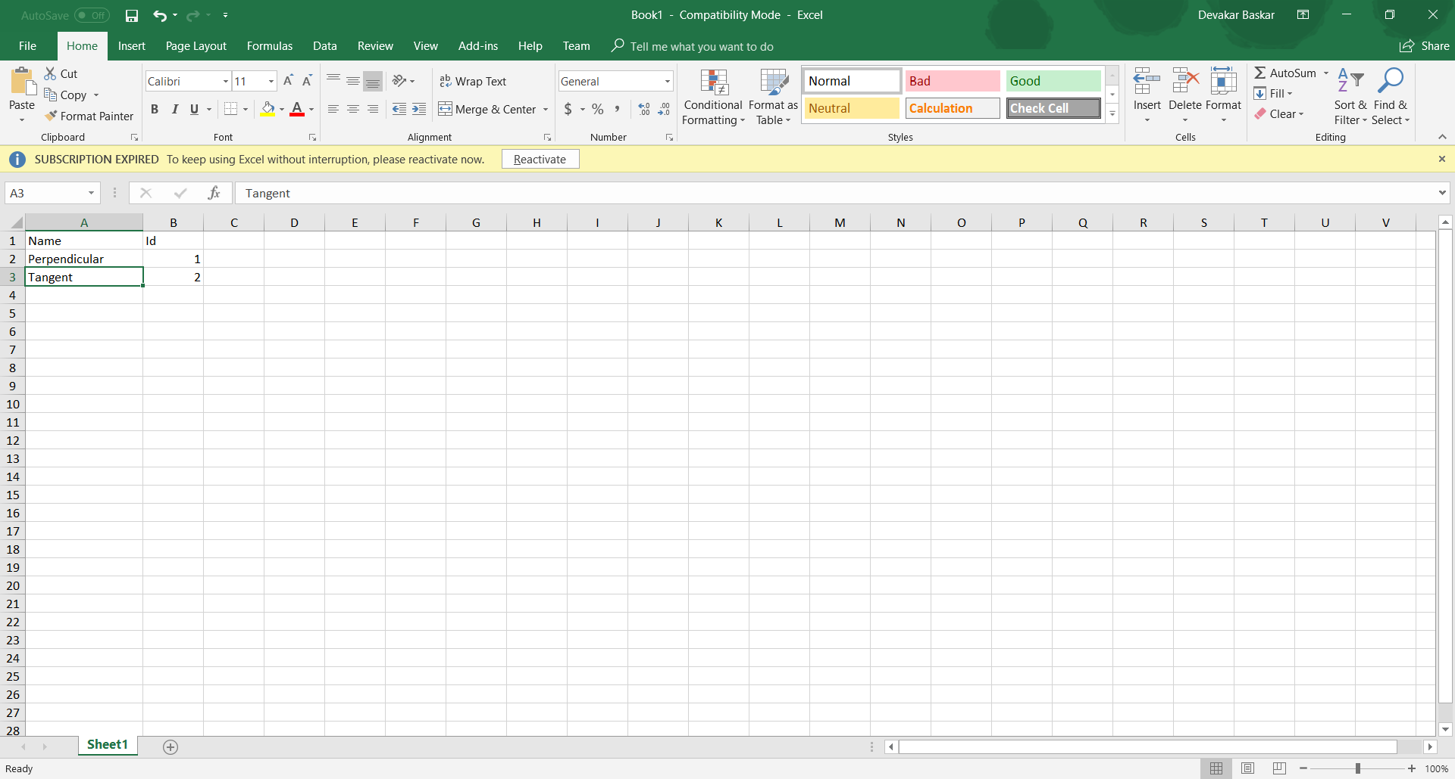

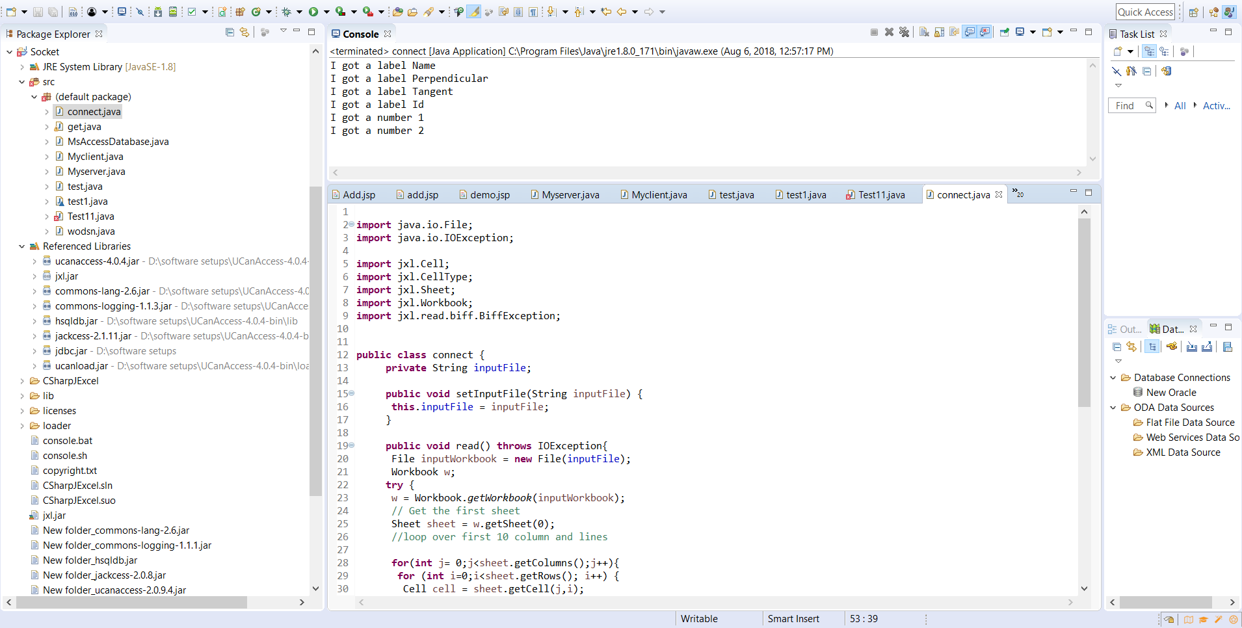

**RESULT:**

Ex:191 **JAVA DATABASE CONNECTIVITY – MS ACCESS**

**Program:**

**import** java.sql.*;

**public** **class** accessconnect {

**public** **static** **void** main(String[] args)

{

**try**

{

Connectionconn=DriverManager.*getConnection*("jdbc:ucanaccess://C:\\Users\\admin\\eclipse-workspace\\enumsam\\Socket\\src\\Theatre1.mdb");

Statement stment = conn.createStatement();

String qry = "SELECT * FROM Hurricane";

ResultSet rs = stment.executeQuery(qry);

**while**(rs.next())

{

String id = rs.getString("Seat") ;

String fname = rs.getString("Availablity");

System.***out***.println("Seat no="+id +"\t" +"Availablity=" +fname +"\n");

}

}

**catch**(Exception err)

{

System.***out***.println(err);

}

//System.out.println("Hasith Sithila");

}}

**Output:**

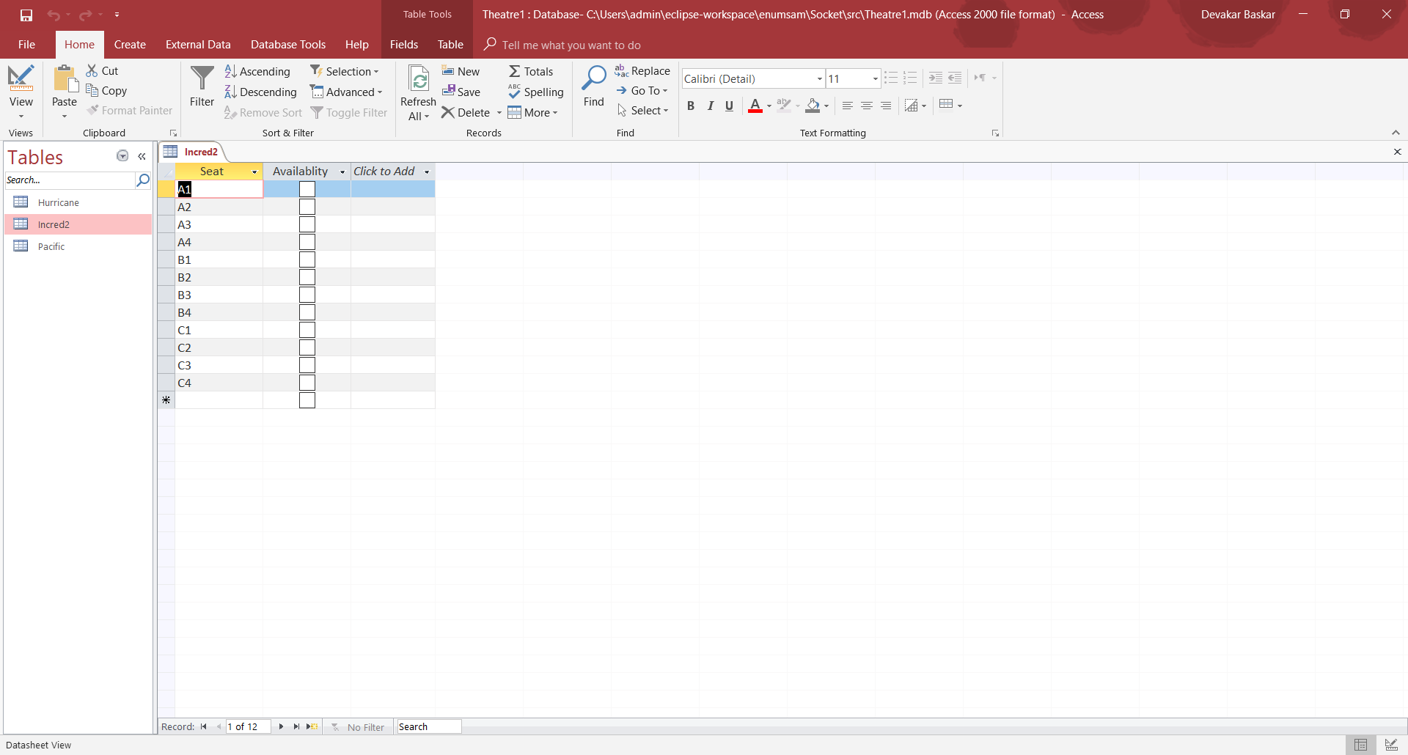

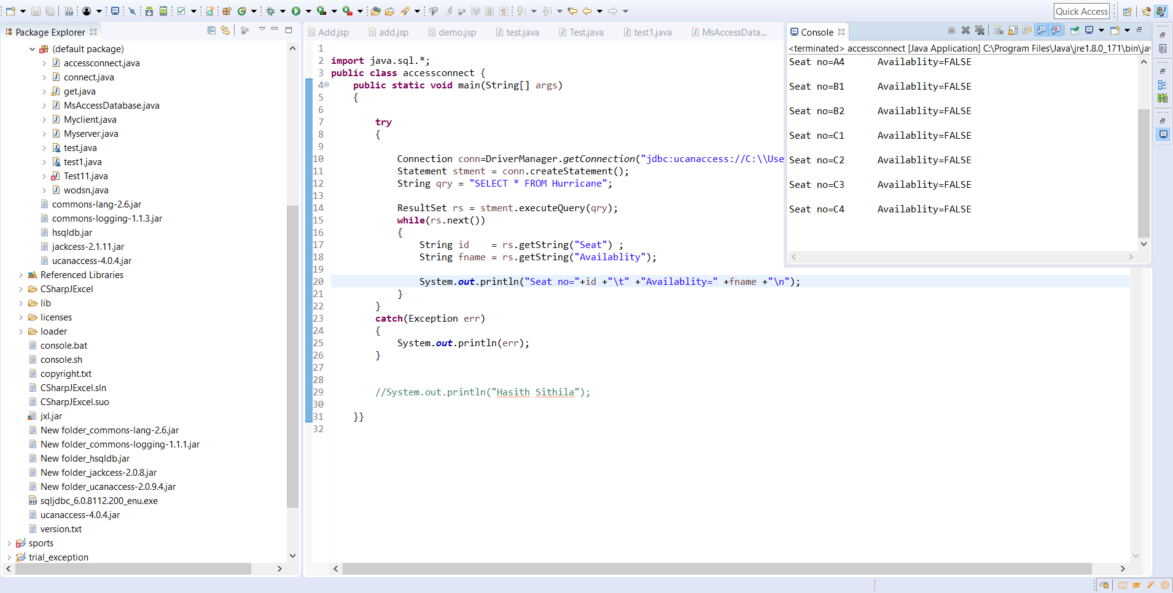

**RESULT:**